**CENG 407**

**BİNEL PROJECT**

**LITERATURE REVIEW**

Duygu DORAN

Fatih ÖNER

Emirhan KARAKAYA

Serkan ŞAHİNOĞLU

Advisor: Murat SARAN

**Contents**

1 Introduction 3

2 Related Technologies 4

2.1 Web Technologies 4

2.1.1 Front-end technologies 4

2.1.2 Backend-end technologies 5

2.2 Mobile Technologies 6

2.2.1 Android 6

2.2.2 iOS 6

2.3 Multiplatform Technologies 7

2.3.1 React 7

2.3.2 Flutter 8

2.3.3 .NET Multi-platform App UI (MAUI) 9

2.4 Database Technologies 10

2.4.1 Relational Database Management Systems 10

2.4.2 NoSQL 13

3 Similar Projects/Systems 14

3.1 Ahbap 14

3.2 HelpKarma 15

3.3 GoFundMe 16

4 Summary 18

5 References 19

# Introduction

This literature review report aims to provide the essential information and context required for the development of the Binel Project. The Binel Project's mission is to create a platform facilitating community contributions and aid. Its primary objective is to promote solidarity among people and integrate this solidarity with social media to reach a broader audience.

While addressing several critical aspects, the report specifically intends to lay the foundation for understanding the project's key components and challenges. These areas encompass essential knowledge fields such as security, database management, user interface design, payment transactions, and personal data protection laws.

This introductory section serves as a summary of the fundamental purpose and scope of the Binel Project. It previews the topics explored throughout the rest of the report. In the subsequent sections, we will detail each project component, discuss how these components can effectively implement challenges overcome, and introduce Related Technologies and similar projects that can be used in the project.

# Related Technologies

## Web Technologies

In today's world, web applications hold significant importance in terms of accessibility and popularity. Having a web application for the BİNEL project is crucial to reach more people and make a greater impact on their lives.

### Front-end technologies

The designs of web applications have effects on factors such as memorability, ease of use, and usage duration. Therefore, it is important for the web application developed for the BİNEL project to have a well-crafted design.

During the creation of designs for web applications, the utilized technologies and their respective areas of use are as follows:

* HTML (Hypertext Markup Language): It is a markup language that allows the creation of the structure of a website with its elements. It also facilitates the grouping of related elements within this structure, providing the opportunity for other design technologies (CSS, JavaScript) to make changes and modifications.
* CSS (Cascading Style Sheets): This style language is used for coloring and sizing designs. It involves making adjustments to HTML elements with specific definitions, enhancing their visual appeal.
* JavaScript: This programming language is employed for achieving a more dynamic appearance of web pages. It is used for transmitting input from forms and similar fields to the backend of the application. Before transmission, necessary adjustments are made to ensure proper functionality.
* Bootstrap is both a framework and a library designed for the development of web applications using HTML, CSS, and JavaScript. It includes components and style templates crafted with these technologies. It is highly useful for creating responsive designs in web applications.

### Backend-end technologies

A web application's unseen part, known as the backend, is fundamentally where processes such as data processing, management, and storage take place in the backend of the application.The web application planned to be created for the BİNEL project requires a backend structure to execute the defined functions.

When developing web applications, utilizing frameworks supported by the programming languages helps contribute to the creation of a secure, fast, and efficient application with established rules and pre-built foundational tools.

Examples of programming languages commonly used for backend development include PHP, JavaScript, Python, Java, and .NET (C#).

Here are some examples of backend frameworks:

* Django: An open-source framework developed for the Python programming language, Django provides ease for developers in terms of scalability and customization. Besides popular Python features, it offers developers and administrators an admin interface.
* Laravel: Laravel is an open-source PHP framework. It provides developers with advanced library and API support and is often preferred for blog, e-commerce, and news websites. It has a structure compatible with relational databases.
* ASP.NET: ASP.NET is a free, open-source framework. Preferred for real-time web applications, ASP.NET offers developers rich API services and microservices.

## Mobile Technologies

Mobile technologies are one of the fundamental elements of the completion of the BİNEL project. The project is based on modern and powerful mobile technologies for applications for Android and iOS platforms.

### Android

The Android application development process of the BİNEL project focuses on Android Studio, a powerful integrated development environment. This official IDE is designed to enable effective development of Android applications. The strong emulator support and extensive plugin ecosystem offered by Android Studio offer developers a fast and efficient working environment. Kotlin programming language has been established as the preferred language for modern and effective development of Android applications. Kotlin's expressive and secure nature provides developers with a more effective coding experience. One of the core technologies used on the Android side of the project is Android Jetpack. This collection of libraries and tools simplifies the development process by including core components such as database management, user interface design, and more.

### iOS

For iOS application development, Xcode is used as an official IDE. This platform offers developers a comprehensive set of tools to manage debugging, interface design, and app deployment of iOS apps.

Swift programming language stands out as a modern, safe and fast language used in the development of iOS applications. This language, developed by Apple, encourages effective code writing on the iOS side of the project.One of the core technologies used for iOS is Cocoa Touch. This specially designed library includes core components such as UIKit (user interface), Core Data (database management). In this way, a comprehensive mobile application experience is provided by using the basic building blocks required for the development of iOS applications in the project.

## Multiplatform Technologies

In the realm of software development, multiplatform technologies play a crucial role in enabling developers to build applications that can run on various operating systems or platforms. This approach is beneficial for reaching a wider audience, reducing development time, and maintaining a single codebase for different platforms. After establishing the significance of employing multiplatform technologies for reaching a broader audience, optimizing development time, and maintaining a unified codebase, we will now delve into the details of three prominent frameworks: React, Flutter, and .NET Multi-platform App UI (MAUI).

### React

React is a JavaScript library for building user interfaces. Developed and maintained by Facebook, React allows developers to create reusable UI components. One of its key features is the ability to efficiently update and render components based on changes in application state. React follows a declarative approach, making it easier to understand and debug code.

React can be used for building web applications, and it has been widely adopted for its simplicity and flexibility. Additionally, React Native, a framework built on top of React, extends its capabilities to mobile app development, allowing developers to write mobile applications using React and JavaScript.

React incorporates key features that contribute to its effectiveness in building user interfaces. One notable feature is the Virtual DOM, which enhances rendering efficiency by utilizing a virtual representation of the DOM. The framework also promotes a Component-Based Architecture, fostering the creation of modular and reusable components for streamlined UI management. Additionally, React adopts a Unidirectional Data Flow approach, ensuring that data within the application moves in a single direction, simplifying the handling of the application state.

### Flutter

Flutter, an open-source UI software development toolkit created by Google, is designed for building natively compiled applications across mobile, web, and desktop platforms from a unified codebase. The framework utilizes the Dart programming language and employs a reactive programming style.

One of Flutter's standout features is its Widget-Based Framework, which treats every element as a widget. This approach facilitates the creation of structural elements, styling, and layouts. Notably, Flutter supports a Hot Reload feature, allowing developers to witness real-time changes in the app during development, thereby expediting the coding process.

What sets Flutter apart is its ability to enable Cross-Platform Development, allowing developers to write code once and deploy it on various platforms, including iOS, Android, web, and desktop. Flutter also provides a seamless user experience by offering widgets for both Material Design (Android) and Cupertino (iOS) styles, ensuring a native look and feel across different platforms.

Flutter originated as an experiment by members of Google's Chrome browser team to build a fast rendering engine that ignores traditional layout models. Widgets serve as the fundamental building blocks of Flutter applications, and everything is treated as a widget. This widget-centric approach simplifies layout by having each widget specify its layout model, resulting in optimized layout and performance gains.

Built using C, C++, Dart, and the Skia graphics engine, Flutter offers a unified object model where everything is a widget, and it provides its widgets rather than relying on platform-specific ones. Although Flutter is a fast and highly customizable tool, it has a relatively young ecosystem compared to alternatives like Multi-OS Engine and Kotlin/Native.

In contrast, Multi-OS Engine and Kotlin/Native communicate with the platform through native tools and widgets. While they facilitate code sharing, they still require native development for each platform. Flutter, on the other hand, employs its widgets and rendering mechanics, offering a high degree of customization and performance. The choice between Flutter and other tools depends on project requirements, team expertise, and platform-specific considerations.

### .NET Multi-platform App UI (MAUI)

.NET MAUI is a powerful framework that streamlines cross-platform development by allowing developers to write code once and deploy it seamlessly across multiple platforms, reducing development effort and promoting code reusability. Leveraging the foundation of Xamarin.Forms, MAUI inherits expertise in cross-platform development and utilizes Xamarin's extensive library of plugins, bindings, and NuGet packages within .NET MAUI applications. The framework offers platform flexibility, supporting iOS, Android, macOS, and Windows, allowing developers to reach a diverse audience without the need for significant platform-specific modifications. MAUI embraces modern C# language features, incorporating the latest advancements in the .NET ecosystem, providing developers with productivity enhancements and language improvements from recent .NET releases.

One of MAUI's standout features is its adaptive UI and controls, automatically adjusting their appearance based on the platform and device characteristics. This ensures a native look and feel on each supported platform, enhancing the overall user experience. Furthermore, MAUI seamlessly integrates with popular development tools such as Visual Studio and Visual Studio Code, allowing developers to leverage familiar environments for coding, debugging, and testing their .NET MAUI applications. The framework also supports cross-platform libraries and packages, enabling the sharing of code for common functionalities across different platforms. Adopting the Model-View-Update (MVU) architecture simplifies the management of application state, user interface, and updates, enhancing the maintainability and scalability of the codebase. In conclusion, .NET MAUI emerges as a robust solution, empowering developers to efficiently create high-quality, cross-platform applications across a variety of devices and operating systems.

## Database Technologies

Relational Databases: SQL-based databases that store data using table structures. Examples include MySQL, PostgreSQL, Oracle, Microsoft SQL Server.

NoSQL Databases: These are non-relational databases with flexible schemas and different data structures. There are various types such as document-based (MongoDB), column-based (Cassandra), key-value-based (Redis).

### Relational Database Management Systems

Relational databases are a type of database that stores and manages data using a standard language called SQL (Structured Query Language). Its main features are:

* Table Structure: Data is stored in tables. Each table represents a specific type of data (for example, users, orders).
* Relationships: Relationships can be established between different tables. These relationships are usually determined using a unique key (primary key). For example, a user may have an order. This relationship can be established between the user's ID and the order's user ID.
* SQL Usage: Accessing, editing, adding or deleting data is generally done using the SQL language. SQL is a widely used language to access and manipulate data in such databases.
* ACID Compliance: Relational databases comply with ACID (Atomicity, Consistency, Isolation, Durability) principles. This ensures the reliability and data integrity of the database. For example, successful completion of transactions, protection of data integrity, etc.
* Data Normalization: Relational databases often organize data using a process called data normalization. This ensures that data is stored consistently and effectively.

Relational databases are widely preferred due to their wide usage and the prevalence of their standard language, SQL. These types of databases are used in many areas, from corporate applications to websites, from financial systems to e-commerce platforms.

**MSSQL**

Microsoft SQL Server (MSSQL) is a database system utilized for storing data in websites or software applications. For instance, in a blog, various data such as articles, comments, user information, among others, can be stored using MSSQL. It stands as the most commonly used database type on Windows-based servers and within various programming languages. Despite not being free, MSSQL is favored due to its provision of advanced and standout features to users.

**What is MSSQL used for?**

MSSQL serves as the database backbone for websites and web software built using the .NET or ASP programming languages within the Windows environment. Connecting to and managing operations on an MS SQL database is notably more straightforward compared to several other programming languages.

SQL Server Management, a creation of Microsoft, functions as a database editor facilitating a wide array of data operations—such as editing, reporting, and analysis—through the utilization of T-SQL commands. These tools enable users to not only establish an MSSQL database but also craft its structure and configure essential settings, essentially engaging in the intricate process of database design.

**What is T-SQL (Transact-SQL)?**

T-SQL, known as Transact-SQL, serves as the query language utilized to execute various operations—such as adding, modifying, querying, or deleting data—within the MS SQL Server database. While not a standalone programming language, it functions as a sub-language resembling programming constructs. This language structure bears similarity in other databases as well; for instance, in databases like MySQL and Oracle, you can perform queries using a comparable syntax.

**PostgreSQL**

PostgreSQL is a powerful, enterprise-level open-source relational database. It allows the use of both relational SQL and non-relational JSON data and queries. PostgreSQL is backed by a robust community. It's an extremely reliable database management system that offers excellent support, security, and accuracy. Several mobile and web applications utilize PostgreSQL as their default database. Many geospatial and analytic solutions also benefit from PostgreSQL. The latest version is PostgreSQL 15.

**GENERAL FEATURES**

PostgreSQL's popularity is largely due to its features. The database assists in application development while maintaining data integrity, enabling administrators to create robust, error-resistant environments. It's versatile across various platforms and supports all common programming languages. We'll see the full list later. The database also offers an advanced locking system and supports concurrency control with various versions. The PostgreSQL database server also possesses mature server-side programming functionalities. It complies with the ANSI SQL specification and fully supports client-server network architecture. Furthermore, PostgreSQL provides high availability and a backup server. It's ANSI-SQL2008 compliant and object-oriented. Its ability to connect to other data warehouses, like NoSQL, as a unified center for multilingual systems, is enabled by the database's JSON support. Information within a database cluster is always managed by a PostgreSQL instance. The database cluster is a group of records held in the same location on the file system.

**How PostgreSQL differs from SQL?**

We've seen that PostgreSQL supports the latest versions of SQL. But how exactly do they differ? Oracle Corporation owns MySQL, which has various premium versions requiring payment from users. In contrast, PostgreSQL is a free and open-source database. Unlike PostgreSQL, MySQL is fully ACID compliant only when used with NDB and InnoDB Cluster Collection engines. In scenarios like OLAP and OLTP applications, where read performance is the key factor, MySQL performs well. However, PostgreSQL's performance is optimal for applications requiring complex query processing. MySQL tends to struggle with challenging business intelligence projects, whereas PostgreSQL excels in analytical and storage applications.

### NoSQL

NoSQL is a database technology that easily stores data in flexible, scalable schemas. For decades, the dominant data model in application development stored data in tables comprising rows and columns, known as the relational data model. Structured Query Language (SQL) was used to create and manipulate these relational tables. The significant adoption and use of other flexible data models began in the mid to late 2000s, leading to the term NoSQL, distinguishing these new database and data model classes from others.

**What are the advantages of NoSQL databases?**

Modern applications face various challenges that can be addressed by NoSQL databases. For instance, applications handle large volumes of data from diverse sources like social media, smart sensors, and third-party databases. Not all this varied data fits perfectly into the relational model. Implementing table structures can lead to issues like redundancy, data replication, and performance problems at a large scale. NoSQL databases are specifically designed for non-relational data models and offer flexible schemas for building modern applications. They have gained broad acceptance due to their ease of development at scale, functionality, and performance. The benefits of NoSQL databases are listed below.

**Flexibility**

NoSQL databases are known for their adaptable schemas, facilitating quicker and iterative software development. Their versatility in handling semi-structured and unstructured data renders them well-suited for various data models.

**Scalability**

The design of NoSQL databases focuses on scalability through the expansion of distributed hardware clusters rather than relying on costly and robust servers. In certain cases, cloud providers handle this scaling as a seamlessly managed service in the background.

**High Performance**

NoSQL databases are finely tuned for specific data models and access methods, delivering superior performance in comparison to executing analogous functions within relational databases. Furthermore, these databases present robust APIs and tailored data types meticulously crafted to suit each relevant data model, contributing significantly to their overall functionality.

# Similar Projects/Systems

## Ahbap

Ahbap is a non-governmental organization founded by musician and philanthropist Haluk Levent. Serving as a solidarity-based platform, Ahbap is involved in various areas, including emergency assistance and search and rescue operations, healthcare services, basic needs support, and student scholarships. Additionally, Ahbap conducts activities related to animal rights, humanitarian aid, and natural disaster coordination. Ahbap is recognized as a charitable platform that upholds principles of social solidarity and valuing human life. On the homepage of Ahbap.org, there are direct call-to-action buttons for those who wish to make donations, labeled as "Donate" and for those seeking assistance, labeled as "Request Help." Additionally, recent news related to current events is displayed to provide opportunities for making donations. To request help, you need to sign up on the website and provide some information, but donating has been simplified for everyone, requiring only an email address and a phone number.During the final step of the donation process, donors are asked to accept certain agreements and provide their card information.

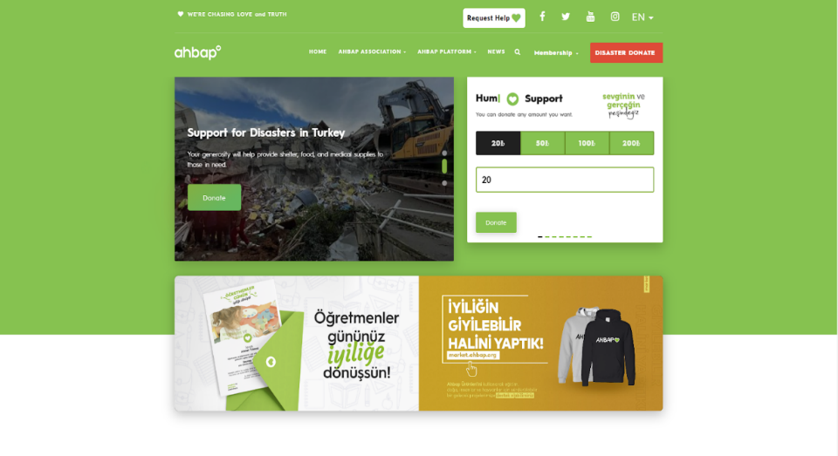

  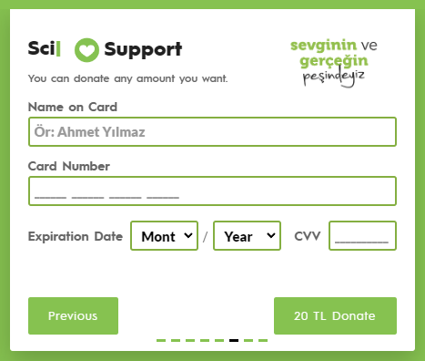

## HelpKarma

The aim of this platform is to create an effective donation culture by bringing together donors and those in need. The main goals set in the project include increasing community donations, providing easy access to those in need, ensuring trust and transparency, and facilitating the donation process using technology. The goal of increasing community giving aims to encourage a variety of individuals, organizations and companies to donate, supported by donor incentives in different categories. In this way, it is aimed to support projects that will contribute to the general welfare of the society.

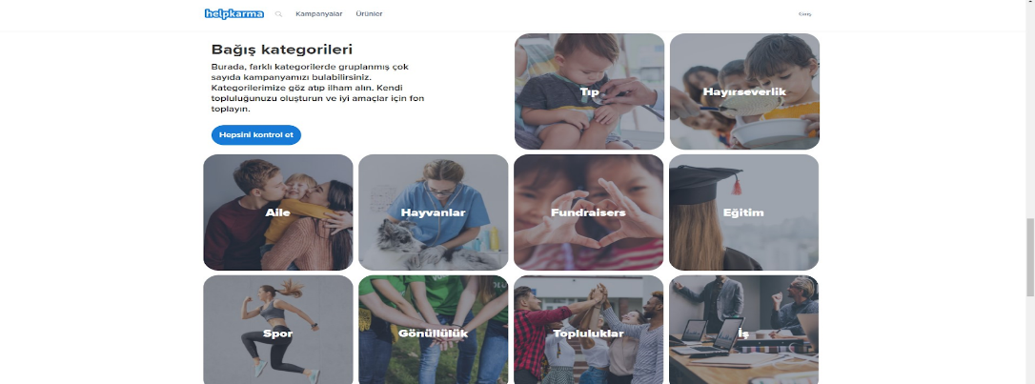

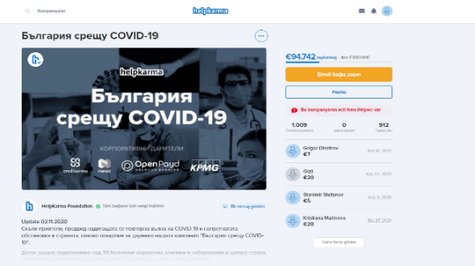 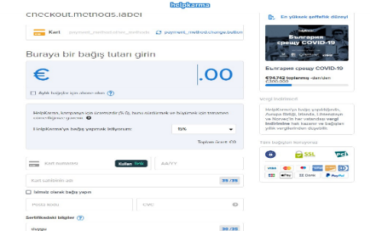

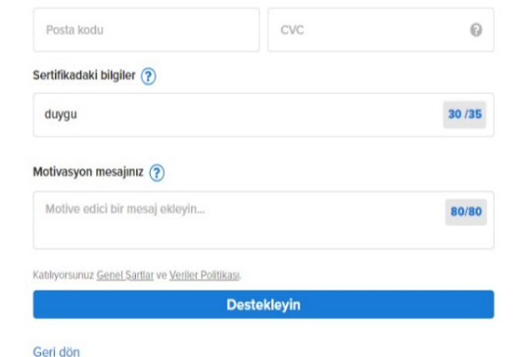 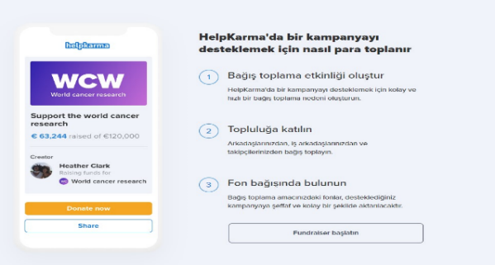

## GoFundMe

GoFundMe is an online platform designed for individuals and groups aiming to raise money for various purposes. This platform allows users to launch fundraising campaigns for personal goals, community projects, or urgent needs and receive donations from supporters. For instance, an individual can start a campaign to cover their healthcare expenses, while someone affected by a disaster or in urgent need can organize a campaign for immediate assistance. Similarly, a school or community can fundraise for specific purposes like educational programs or community projects. GoFundMe enables users to create, promote, and gather donations for their campaigns through social media or other communication channels. Donors can contribute to the campaigns they choose, and the funds raised through this platform are typically directed toward a specific purpose. This platform fosters a culture of social support and solidarity by facilitating people in helping each other, supporting communities, and coming together to meet various needs.

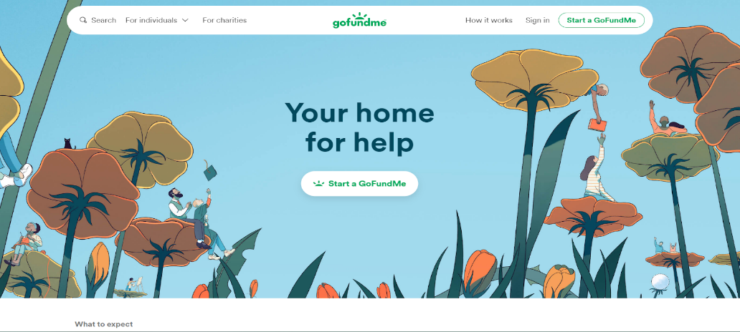



# Summary

In summary, the results obtained from the literature review indicate that the BİNEL project can be implemented using various technologies. As exemplified by charitable platforms, incorporating different features can aid in assisting people and making the platform more unique. The information gathered from this literature review will be utilized to identify and meet the requirements for the development of the BİNEL project.

# References

[1] DB-Engines, “DB-Engines Ranking,” DB-Engines, 2023. https://db-engines.com/en/ranking

‌[2] J. Fayzullaev, “Native-like Cross-Platform Mobile Development : Multi-OS Engine & Kotlin Native vs Flutter,” www.theseus.fi, 2018. https://www.theseus.fi/handle/10024/148975

[3] L. Ma, L. Gu, and J. Wang, “Research and Development of Mobile Application for Android Platform,” International Journal of Multimedia and Ubiquitous Engineering, vol. 9, pp. 187–198, 2014.

[4] Vargonen, “MsSQL ve MySQL Nedir?,” Vargonen Blog, Mar. 17, 2020. https://www.vargonen.com/blog/mssql-ve-mysql-nedir/

[5] “Information on 480 Database Management Systems,” db-engines.com. https://db-engines.com/en/systems (accessed Nov. 15, 2023).

[6] “İlişkisel - İlişkisel Olmayan Veri Tabanı Karşılaştırması - Veri Tabanı Türleri Arasındaki Fark - AWS,” Amazon Web Services, Inc. https://aws.amazon.com/tr/compare/the-difference-between-relational-and-non-relational-databases/ (accessed Nov. 15, 2023).

[7] “İlişkisel ve NoSql Veritabanları Lesson,” Patika Dev, Jul. 06, 2021. https://academy.patika.dev/courses/net-core/1-iliskisel-nosql-veritabanlari (accessed Nov. 15, 2023).

[8] “PostgreSQL nedir? | AppMaster,” appmaster.io. https://appmaster.io/tr/blog/postgresql-nedir (accessed Nov. 15, 2023).

[9] A. Digital, “Microsoft SQL Server Nedir?, Ne İçin Kullanılır?,” GTech, Apr. 11, 2022. https://www.gtech.com.tr/microsoft-sql-server-nedir-ne-icin-kullanilir (accessed Nov. 15, 2023).

[10] A. Booking, “What is Bootstrap? An In-depth Guide of the Framework,” Amelia Booking WordPress Plugin, Jun. 06, 2019. https://wpamelia.com/what-is-bootstrap/

[11] “Top 7 Frameworks For Backend Development,” GeeksforGeeks, Jun. 05, 2022. https://www.geeksforgeeks.org/top-7-frameworks-for-backend-development/

[12] “HTML, CSS, and JavaScript: Your Guide to Learning Fundamental Front End Languages,” UT Austin Boot Camps, Oct. 22, 2021. https://techbootcamps.utexas.edu/blog/html-css-javascript/#:~:text=If%20you%27re%20trying%20to (accessed Nov. 15, 2023).

[13] QServices, “ASP.NET: An In-Depth Introduction and Comprehensive Tutorials,” Medium, Jun. 08, 2023. https://medium.com/@seoqservicesit/asp-net-an-in-depth-introduction-and-comprehensive-tutorials-6cbc7a7f0b80 (accessed Nov. 15, 2023).